Materials: | Leather | Stitching | Exotic Leather | Suede  (Liner) | Pig Skin  (liner)
Colors : | Mahogany | Orange | Elephant with texture | Royal Blue | Black
All colors vary with leather | Saddle Tan | Blue Tint Purple | Shark with texture | Emerald Green | Dark Brown
May can get other colors on  request | Dark Brown | Royal Blue | 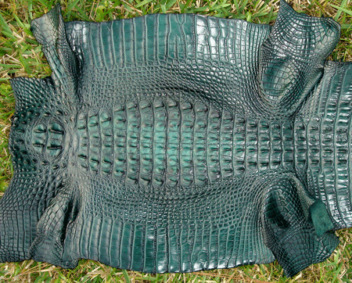Green Alligator | Black
Quotes on request | Black | Yellow | 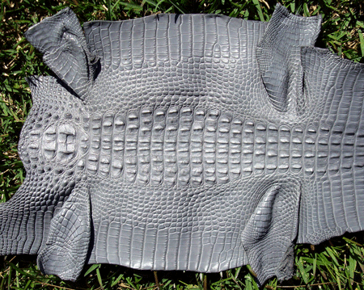Grey Alligator | Purple tint Pink
Color stitching other than black is an additional charge of $15.00(retail) |  | Emerald Green | 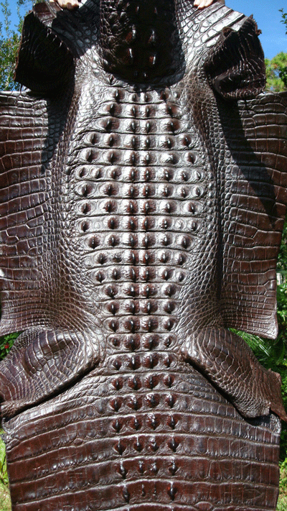Chocolate Alligator | Purple
Liners are an additional $20 (retail) |  | Black | 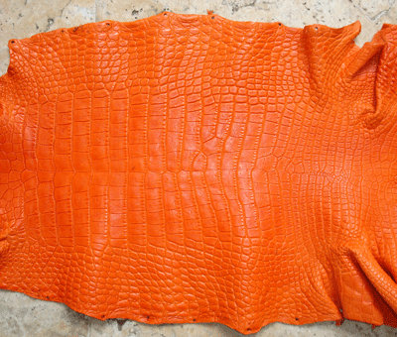Orange Alligator | Tan
Exotic leather varies in price |  | White | 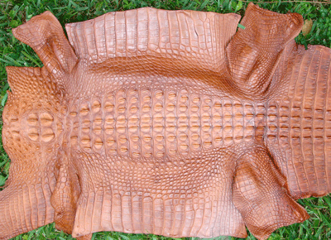Cognac Alligator
Exotic leather can either be trim or in full |  | Red | 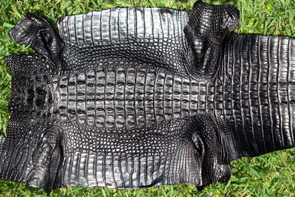Black Alligator
 |  |  | 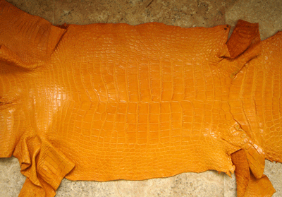Buttercup Alligator
 |  |  | 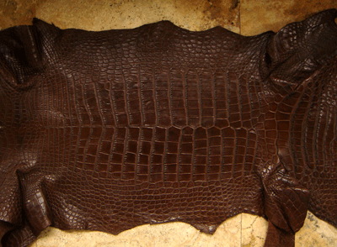Dark Brown Alligator
 |  |  | 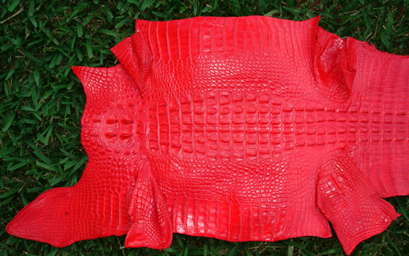 Flame Red Alligator
 |  |  | 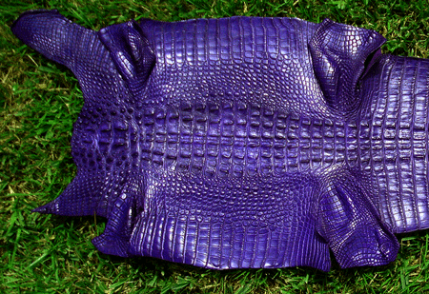 Purple Alligator
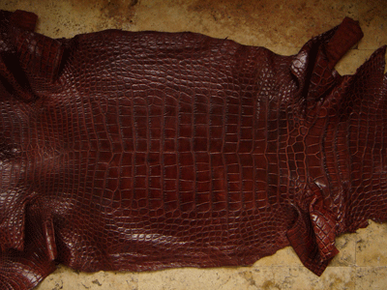
Sport Rust Alligator
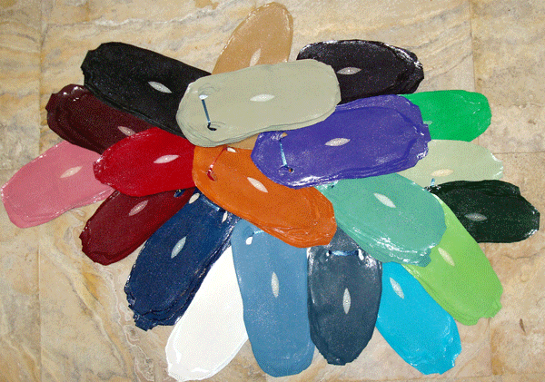
Assorted Colors for StingRay w/Eye
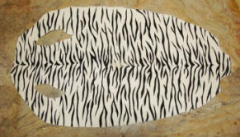
Zebra StingRay
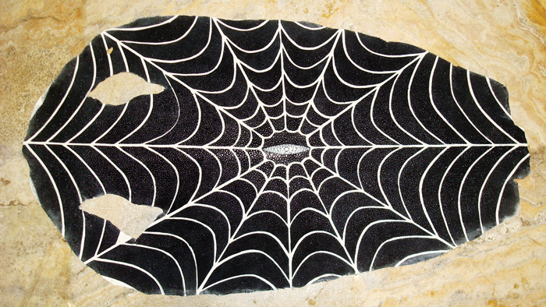
Spider Web StingRay
 |  |  | 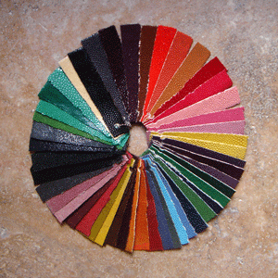Assorted Colors for StingRay
 |  |  | Dark Brown Shark
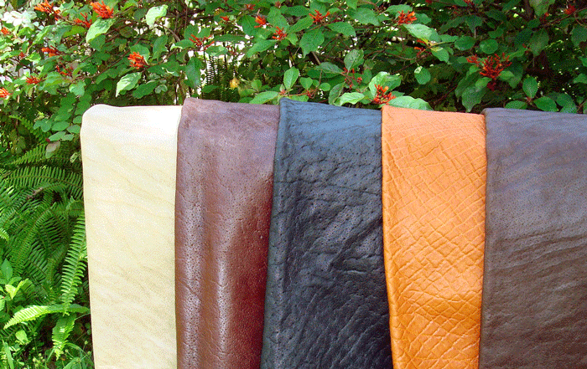
Elephant From Left to Right Sand, Chestnut, Black, Honey, Nicotine
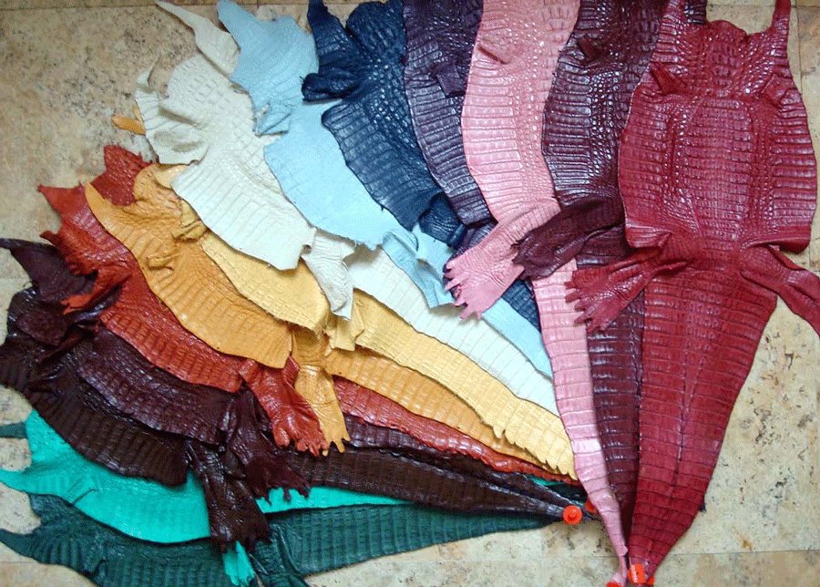
Assorted Colors for Caiman
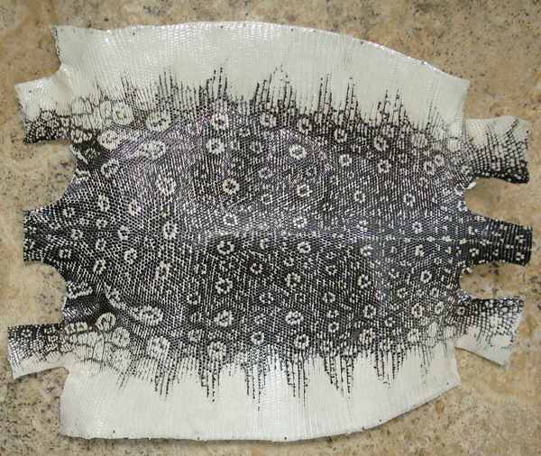
Ring Lizard White
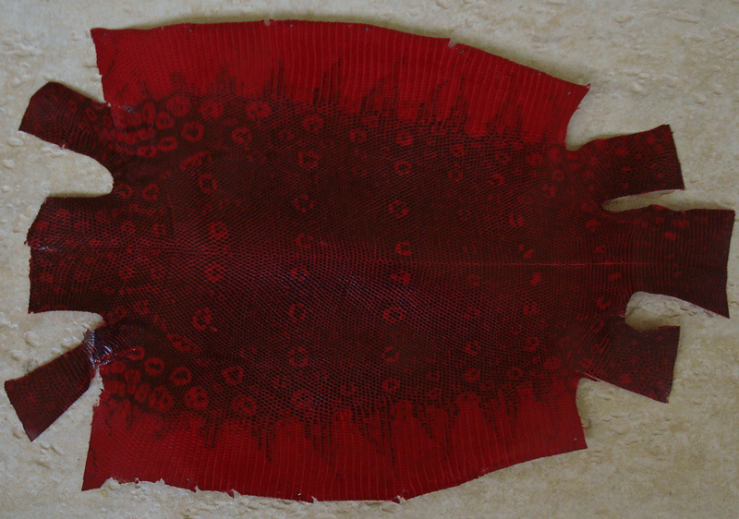
Red Ring Lizard
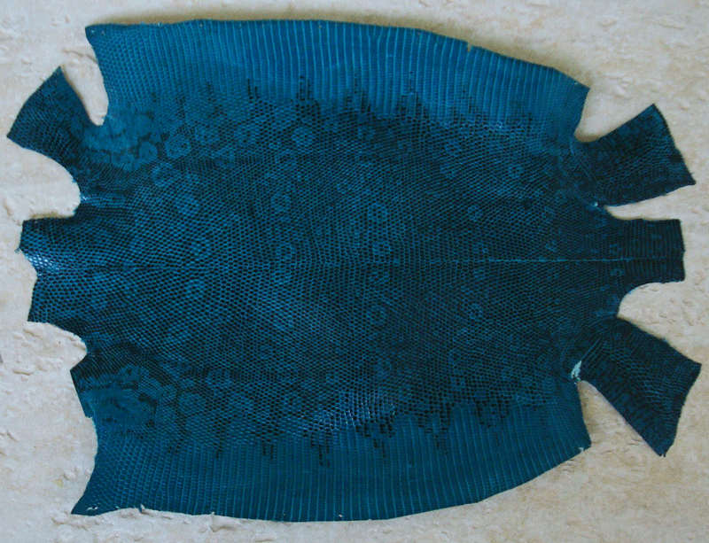
Ring Lizard Turquoise

Ostrich’s Color Chart

